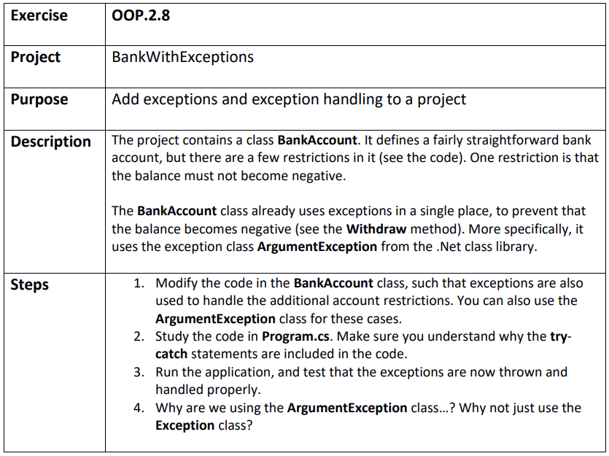

Step 1
BankWithExceptions.sln
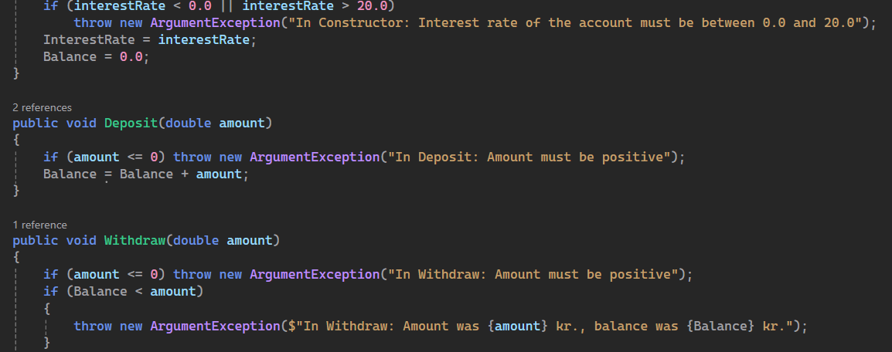

Step 2
To handle the exception without a runtime error if it should occur

Step 4
When using the ArgumentException it makes it easier in the other end to handle that specific exception with a unique strategy. If we just threw an exception it would be difficult to differentiate strategies for handling it.

